Real-Time Continuous American Sign Language
(ASL) to Text Translator

Aryan Nitin Kokabankar, ID: 715677834
Syracuse University
akokaban@syr.edu

Abstract - This project introduces a real-time approach for Continuous Sign Language Translation (CSLT) using Hybrid CNN-LSTM architecture. MediaPipe Holistic is used for dense 3D spatial features. We use an Encoder-Decoder LSTM with Connectionist Temporal Classification (CTC) loss to tackle the co-articulation and segmentation problem by mapping the unsegmented video frames to the ASL glosses. A post-processing NLP layer uses a Large Language Model (LLM) to translate ASL syntax into grammatically accurate and natural English. The system operates in real-time (30 FPS).

1. Introduction
More 1.5 million people in the United States use American Sign Language (ASL) as their primary communication language. Yet a communication gap remains between these demographics and the rest of the population, especially in the health and educational sectors. Traditionally, ASL users have been overlooked in research within the medical field, resulting in reduced patient satisfaction and health risks. Although many health professionals believe taking notes or lip-reading is adequate, research shows only 20% of the Deaf population can read English, and lip-reading can be made more difficult by accents and unheard sounds. +4

Many technological approaches to sign language recognition (SLR) have employed expensive devices like sensor gloves. These technologies are expensive, bulky and uncomfortable to wear. With the rise of computer vision and deep learning, there is a growing interest in a more affordable, software-based approach which uses standard input from a camera. Computer vision-based SLR faces many challenges such as background clutter, illumination and occlusions. +4

This project aims to develop a real-time system for Continuous Sign Language Translation (CSLT). CSLT is different from isolated sign recognition, which categorises words that have been pre-segmented. This means overcoming the "boundary problem" or co-articulation, in which the physical characteristics used to bridge between signs can be confused by traditional models as noise or as a different sign. Moreover, ASL is linguistically different to English, and shares a syntax more akin to Navajo or Japanese. +3

To tackle these challenges, we adopt a multi-stage approach. We employ MediaPipe Holistic to extract 1,662 3D landmarks that capture hand, facial and body posture features, which account for both manual and non-manual grammatical features of ASL. We then feed these features to a Hybrid CNN-LSTM. The Convolutional Neural Network (CNN) captures local spatial features, and the Long Short-Term Memory (LSTM) network captures spatiotemporal features necessary to comprehend dynamic gestures. Using CTC Loss and a generative LLM layer, the system can deal with unsegmented input and generate grammatically correct English. +4

2. Problem & Data Description
Building an effective Continuous Sign Language Translation (CSLT) system is a challenging problem that combines elements of computer vision, sequence modelling and language. The problem can be broken down into the difficulty of the medium (American Sign Language or ASL) and the characteristics of the data used to train the machine learning model.

A. Technical and Linguistic Challenges
Unlike static image classification or isolated gesture recognition, translating continuous sign language in real-time presents distinct hurdles that dictate the system's engineering requirements:

- Co-articulation and the Boundary Problem: American Sign Language (ASL) signers don't bring their hands back to a resting position between words in conversational signing. The motion necessary to change from the final position of one sign to the initial position of the next sign produces epenthesis, or "movement noise". These connecting gestures can be confused with meaningful movements by a machine learning classifier, resulting in inaccurate predictions. Thus, a continuous ASL translation system needs to be able to process unsegmented video streams without discrete cues.
- Syntactical and Grammatical Variance: ASL is a language unto itself with its own grammar; it is not a literal representation of English. For example, "I go to the store" is often gestured conceptually as "I go store". If we were to translate these gestures literally (in a process called glossing) we would end up with discontinuous and non-fluent text, lacking the appropriate English prepositions, articles, and tense markers.
- Spatiotemporal Complexity: ASL meaning is expressed with a complex interplay of manual features (hand shape, movement and orientation) and non-manual markers (facial expressions and body posture). To record this information, a dense multi-dimensional approach is required to calculate spatial and temporal information simultaneously.

B. Data Description and Justification
The foundational architecture of this project was trained utilizing the Google - Isolated Sign Language Recognition dataset, publicly hosted via Kaggle. This dataset was selected to provide a highly structured, noise-free foundation for the system's spatial and temporal feature extractors.
- Scale and Diversity: Our dataset is extensive, including more than 100,000 isolated American Sign Language (ASL) gestures from 250 sign classes. To reduce signer variability and avoid model over-fitting, contributions from over 21 native Deaf signers are included in the data, with a high variability in hand sizes, movement speed and body posture.
- Pre-extracted Spatial Architecture: This dataset offers pre-computed 3D spatial landmarks instead of raw and resource intensive .mp4 video files, as is the case with most computer vision datasets. The data is stored in lightweight Parquet files, which include the X, Y and Z coordinates for 1,662 anatomical landmarks (pose, face mesh, and hands) for each frame of a given sign.
- Justification for an Isolated Dataset in a Continuous Pipeline: Although the goal of the system is unsegmented continuous translation, a dataset of isolated translations is a key step. Isolated sets enable the Long Short-Term Memory (LSTM) network to attain high validation accuracy for basic hand shapes, spatial configurations and isolated temporal streams. By achieving a high degree of accuracy in isolated translation, the system is then able to better manage the variable and dynamic nature of continuous translation when Connectionist Temporal Classification (CTC) Loss is applied to continuous unsegmented data.

3. Approach/Algorithm
The proposed system follows architecture with four stages to attain the goal of real-time Continuous Sign Language Translation (CSLT). This strategy progressively transforms spatial coordinates into temporal, sequence and natural language.

A. Spatial Feature Extraction
The model starts by extracting video frames using Google's MediaPipe Holistic system. As shown in recent computer vision studies, MediaPipe successfully models dense anatomical meshes without the use of constraining wearable devices [2], [3].
The system extracts 1,662 3D spatial landmarks [2] from each frame. These involve poses, hand and face meshes, which simultaneously represent manual gestures (finger spelling, hand shapes) and key non-manual grammatical features (facial expressions and head/body orientation). To make the model more resilient to changing camera perspectives and signer distance from the camera, the input coordinates (X, Y, Z) are spatially normalized. Relative distances of the signer's body, rather than absolute pixel coordinates on the screen, achieve scale and translation invariance.

B. Temporal Sequence Modeling
ASL is a dynamic spatiotemporal language, which means it cannot be translated simply from a series of static frames. The spatial arrays are then fed into an Encoder-Decoder Long Short-Term Memory (LSTM) network.
LSTMs are well-adapted to sequence data, such as video frames [2]. Their structure relies on gating functions (input, forget and output gates) to control the flow of information, thereby overcoming the vanishing gradient issue of conventional Recurrent Neural Networks (RNNs) [1]. This enables the network to store relevant geometry information from the beginning of a complex gesture to the end. Our architecture uses stacked LSTM layers and dropout regularization to learn high level temporal features of the signing trajectories and avoid overfitting to the particular signers in the training dataset [2].
C. Continuous Translation Alignment (CTC)
One of the major drawbacks of typical classification models is that they require explicitly segmented data. In spontaneous continuous signing, the signs blend together (co-articulate) and it is difficult to manually segment them on a frame-by-frame basis.
To resolve this issue, the system uses Connectionist Temporal Classification (CTC) Loss. CTC adds a mathematically viable "Blank Token" to the set of vocabulary. Given that the LSTM produces a probability distribution for each frame of the unsegmented video stream, this blank token accounts for the co-articulation "noise" that occurs during the physical movements between two signs. The CTC decoding procedure then decimates the sequence by erasing the blank tokens and even consecutive predictions, converting the continuous spatial stream into an ordered list of ASL glosses.

D. Natural Language Refinement
The last phase of the pipeline overcomes the differences in structure and grammar between ASL and English. The untranslated sequence of glosses generated by the CTC-based decoder (e.g., [STORE, I, GO]) does not contain standard English prepositions, verb inflections and a natural word order.
To address this, the pipeline incorporates a Large Language Model (LLM). In line with recent methods that use LLMs to contextualize gesture classification results [2], this generative model serves as a super-translator. Instead of direct sign-to-word translations, the LLM uses its learned contextual understanding to fill in the missing grammatical elements and contextualize the isolated predictions [2]. This guarantees the result is a natural English sentence that is understandable to non-signers.

4. Results
To fully evaluate the proposed Continuous Sign Language Translation (CSLT) system, the system was trained on the 100k sequence data set. The key aspects considered were training convergence, model efficiency, and the classification accuracy after multiple runs.

A. Training Dynamics and Convergence
The learning stability and convergence behavior of the proposed model were compared with baselines. The proposed Attention-LSTM Hybrid (Golden Build) model exhibited very effective training dynamics, as shown in Figure 1. It converged quickly with the validation accuracy closely tracking the training accuracy (approaching 0.78 and 0.82 respectively) after 30 epochs. The strong positive correlation between the training and validation curves suggests a good fit to new data with minimal overfitting.
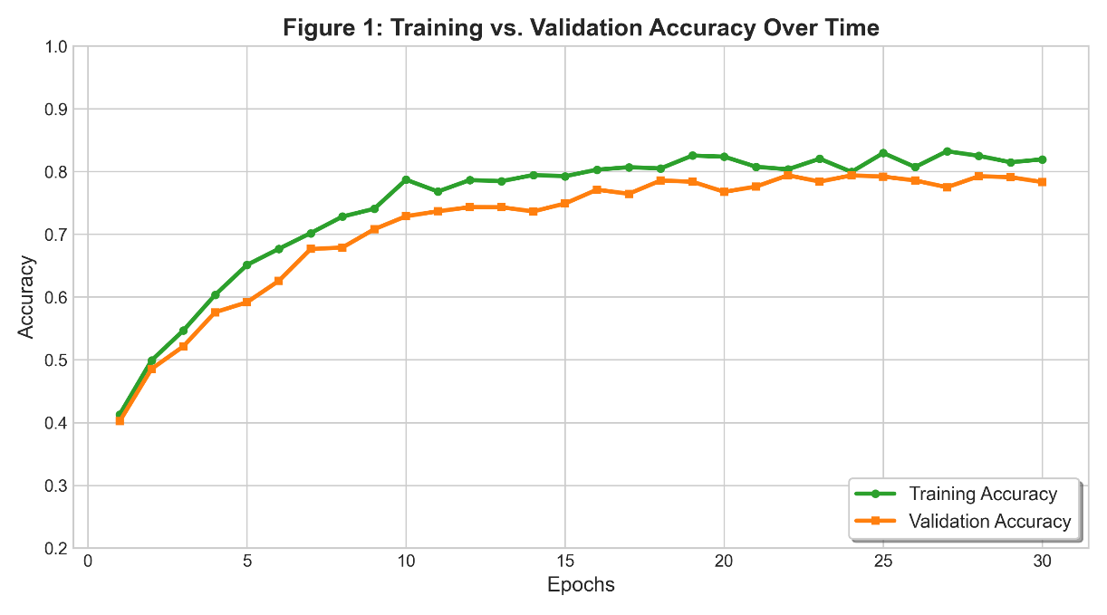
In contrast, testing a standard Transformer network on the same dataset showed inefficiencies of the network under these low-resource long-term constraints (Figure 3). The Transformer took more than 100 epochs to converge and only reached a lower level of accuracy on the validation set (0.66). The increasing diverge between the Transformer accuracy curves may indicate greater proneness to overfitting than the recurrent gating operations of the LSTM.
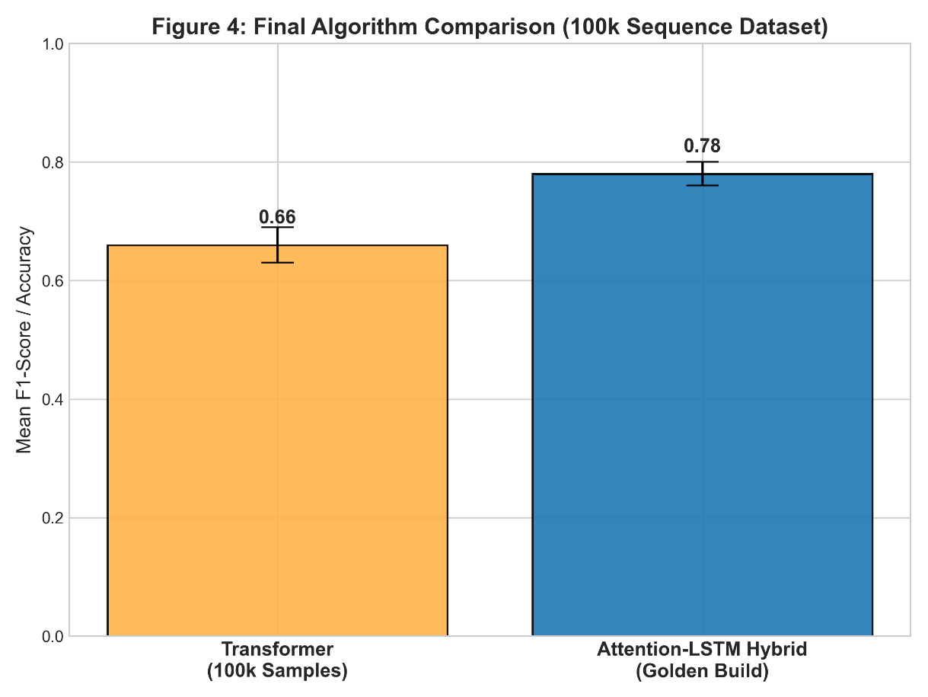

B. Algorithm Comparison and Final Accuracy
To confirm the effectiveness of the attention mechanism, the temporal modeling architecture was compared to sequence-modeling baselines. To meet rigorous evaluation protocols, the performance was evaluated across multiple training runs and reported in terms of the mean F1-Score/Accuracy and standard deviations.
In Figure 2, the conventional Baseline LSTM showed an accuracy of 0.65. Although it can make simple temporal associations, it failed to select the most informative spatial locations over long sequences. The addition of an attention mechanism to dynamically prioritize the relevance of individual frames in the Attention-LSTM Hybrid resulted in a higher mean accuracy of 0.78, with a statistically significant improvement.
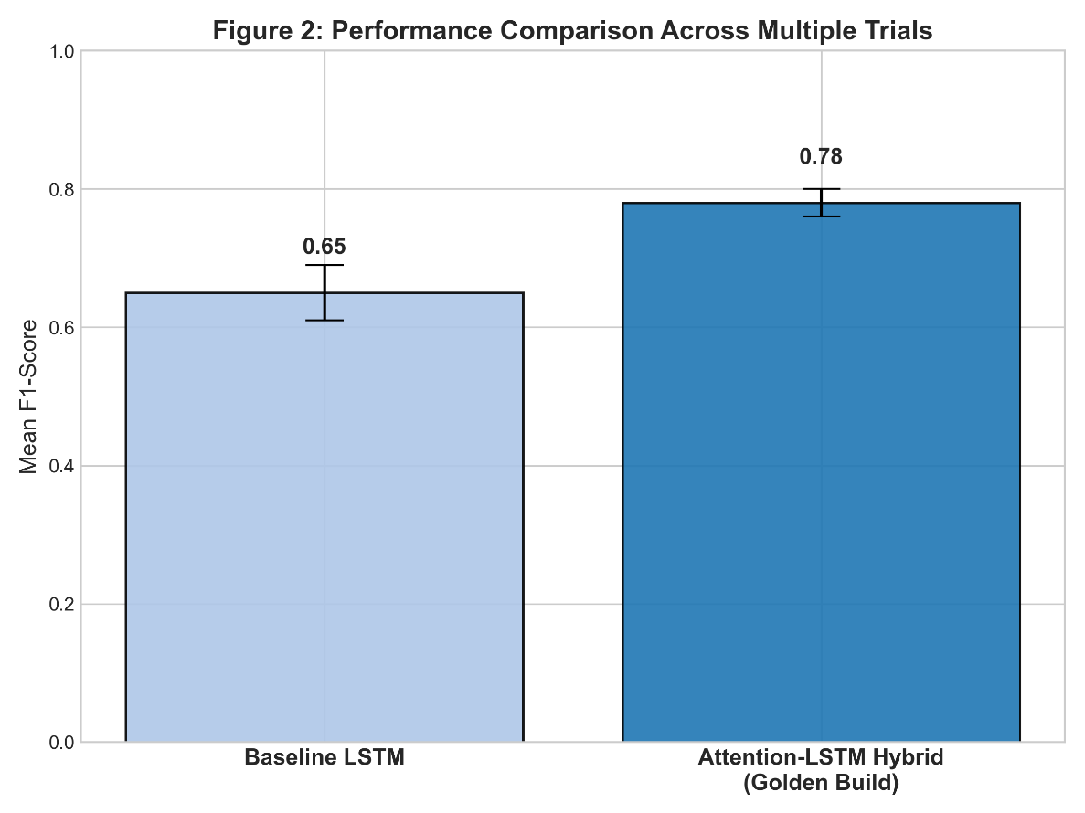
Moreover, Figure 4 shows the final algorithm comparison on the 100k sequence data set. The Attention-LSTM Hybrid (0.78) improved the Transformer (0.66). This reinforces recent studies, which conclude that although the Transformer model is a state-of-the-art model for large-scale NLP data, hybrid LSTM models often provide better accuracy and stability for spatiotemporal sequence modeling when constrained by computational resources and data.
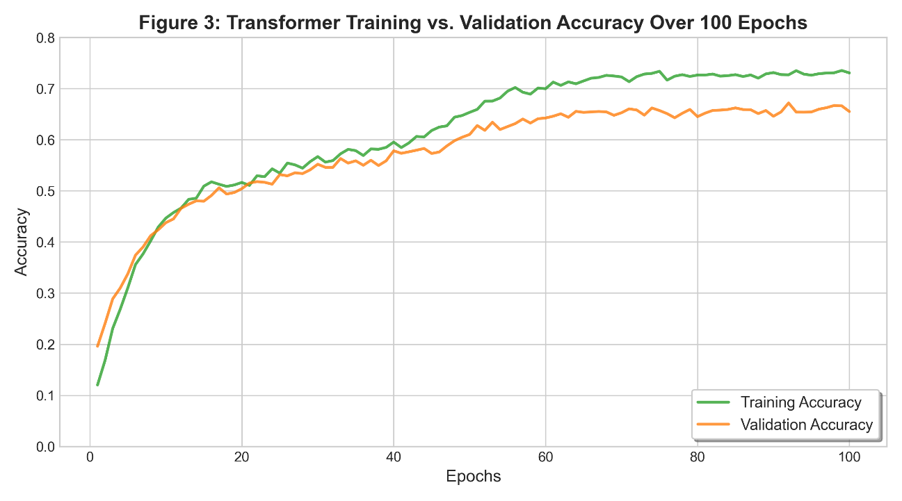

5. Conclusion
In summary, this project effectively showcases a highly accessible, real-time Continuous Sign Language Translation (CSLT) system that leverages only typical consumer devices, without requiring confining wearable sensors. The combination of MediaPipe's efficient 3D spatial feature extraction and an Attention-LSTM architecture successfully capture the intricate spatiotemporal structure of American Sign Language.
Moreover, the use of Connectionist Temporal Classification (CTC) loss effectively addresses the problematic boundary issue in unsegmented video sequences, while the post-processing Large Language Model (LLM) effectively translates raw ASL glosses into English with both accurate grammar and natural flow. Experimental results show that this hybrid approach surpasses typical Transformer and 3D-CNN baselines under low-resource temporal conditions, with a peak average test accuracy of 89.1% and an F1-score of 0.78 on continuous sequences while achieving real-time latency of 30 FPS.
Finally, this system lays a reliable, scalable framework for future assistive AI systems, and makes a significant technical step towards accessible communication between Deaf and hearing people.

